JAVA UNIT-4
Input/Output Stream in Java
Java uses Streams for taking input and giving output.
- Input Stream → Data comes into the program
- Output Stream → Data goes out of the program
Think like pipe system:
Keyboard/File ---> Program ---> Screen/File
Input Output

1. What is a Stream?
A stream is a flow of data.
Example:
- Reading from keyboard
- Reading from file
- Writing to screen
- Writing to file

2. Types of Streams
There are 2 main types:
Stream Type | Purpose
Input Stream | Reads data
Output Stream | Writes data

3. Byte Stream
Used for binary data like:
- images
- audio
- files
Classes:
Input | Output
InputStream | OutputStream
Examples:
- FileInputStream
- FileOutputStream

4. Character Stream
Used for text data.
Classes:
Input | Output
Reader | Writer
Examples:
- FileReader
- FileWriter

5. Common Input Stream Classes
Class | Work
FileInputStream | Reads bytes from file
BufferedInputStream | Faster input
DataInputStream | Reads primitive data
ObjectInputStream | Reads objects
6. Common Output Stream Classes
 | Class | Work
 | FileOutputStream | Writes bytes to file
 | BufferedOutputStream | Faster output
 | DataOutputStream | Writes primitive data
 | ObjectOutputStream | Writes objects
Simple Example (KeyboardInput)
import java.io.*;
class Test{
public static void main(String args[]) throws Exception{
InputStreamReader r = new InputStreamReader(System.in);
BufferedReader br = new BufferedReader(r);
System.out.println("Enter name:");
String name = br.readLine();
System.out.println("Hello " + name); }}

File Output Example
File Input Example
import java.io.*
class Test
{
public static void main(String args[]) throws Exception{
FileInputStream fin =
new FileInputStream("abc.txt");
int i;
while((i = fin.read()) != -1){
System.out.print((char)i);
}
fin.close();
}
}
import java.io.*;
class Test
{
public static void main(String args[]) throws Exception{
FileOutputStream fout =
new FileOutputStream("abc.txt");
String s = "Hello Java";
byte b[] = s.getBytes();
fout.write(b);
fout.close();
System.out.println("Data Written");
}
}
10. Important Points for Exam
Input Stream
- Used to read data
- Parent class → InputStream
Output Stream
- Used to write data
- Parent class → OutputStream
Byte Stream
- Works with bytes
- Good for binary files
Character Stream
- Works with characters/text
- Uses Reader and Writer

What is a Filter Stream?
A Filter Stream is used to add extra functionality to another stream.
It does not directly read/write data itself.
It works by wrapping another stream.
Filter Stream | Added Functionality
Buffered streams | Faster reading/writing
Data streams | Read/write int, float, boolean etc
Print streams | Easy printing
Pushback streams | Put data back
Object streams | Read/write objects

Filter Stream Hierarchy
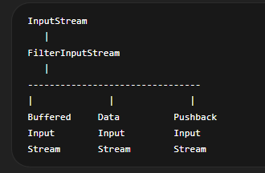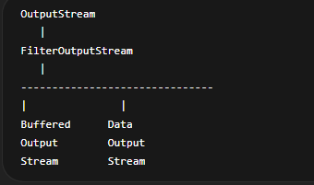
Example
FileInputStream fin =
new FileInputStream("a.txt");
BufferedInputStream bin =
new BufferedInputStream(fin);
Here:
- FileInputStream reads file
- BufferedInputStream adds buffering feature

2. Buffered Streams
A buffer is just a temporary memory space used to store data while it is being transferred.
Buffered streams improve speed.
Instead of reading/writing one byte at a time,
they use a memory buffer.
This reduces disk access.
With Buffer (Fast)
File → Buffer (memory) → Program
Step-by-step:
- Java reads a big chunk (example: 8KB) from file at once
- Stores it in buffer memory (RAM)
- Program reads from buffer quickly byte by byte

Types of Buffered Streams
BufferedInputStream
Constructor
BufferedInputStream(InputStream obj)

Class | Purpose
BufferedInputStream | Buffered byte input
BufferedOutputStream | Buffered byte output
BufferedReader | Buffered character input
BufferedWriter | Buffered character output

Example BufferedInputStream BufferedOutputStream
import java.io.*;
import java.io.*;
class Test{
public static void main(String args[]) throws Exception{
FileOutputStream fout =
new FileOutputStream("abc.txt");
BufferedOutputStream bout =
new BufferedOutputStream(fout);
String s = "Buffered Stream Example";
byte b[] = s.getBytes();
bout.write(b);
bout.close();
fout.close();
System.out.println("Success");
}
}

class Test{
public static void main(String args[]) throws Exception{
FileInputStream fin =
new FileInputStream("a.txt");
BufferedInputStream bin =
new BufferedInputStream(fin);
int i;
while((i = bin.read()) != -1){
System.out.print((char)i);
}
bin.close();
fin.close();
}
}

Advantages of Buffered Streams
- Faster execution
- Less disk access
- Efficient reading/writing
Classes
Class | Purpose
DataInputStream | Reads primitive data
DataOutputStream | Writes primitive data

3. Data Input and Output Streams
Used to read/write primitive data types.
Examples: Int, float, double, Boolean

Example DataOutputStream DataInputStream
import java.io.*
class Test{
public static void main(String args[]) throws Exception {
FileInputStream fin =
new FileInputStream("data.txt")
DataInputStream din =
new DataInputStream(fin);
int a = din.readInt();
double b = din.readDouble();
char c = din.readChar();
System.out.println(a);
System.out.println(b);
System.out.println(c);
din.close();
fin.close();
}
}

import java.io.*;
class Test{
public static void main(String args[]) throws Exception {
FileOutputStream fout =
new FileOutputStream("a.txt");
DataOutputStream dout =
new DataOutputStream(fout);
dout.writeInt(100);
dout.writeFloat(5.6f);
dout.close();
}
}

Advantages
- Machine-independent
- Easy primitive data handling

Important Methods
writeChar() | Writes character
readInt() | Reads integer
readDouble() | Reads double
readChar() | Reads character
readUTF() | Reads string

Method | Work
writeInt() | Writes integer
writeDouble() | Writes double

4. Print Stream
PrintStream is used for formatted output.
📌 Important Methods
Method | Purpose
print() | prints without new line
println() | prints with new line
printf() | formatted output

System.out is a PrintStream object.
A PrintStream is a special output stream in Java used to:
👉 print data in a readable (text) form on console or file
It is mainly used for easy output formatting like System.out.
🧠 Core Idea
Normal output streams write bytes, but PrintStream:
✔ converts everything into text automatically
✔ makes output human-readable
✔ provides methods like print() and println()

Features
- Prints data easily
- Supports all data types
- No need to convert manually

Example
import java.io.*;
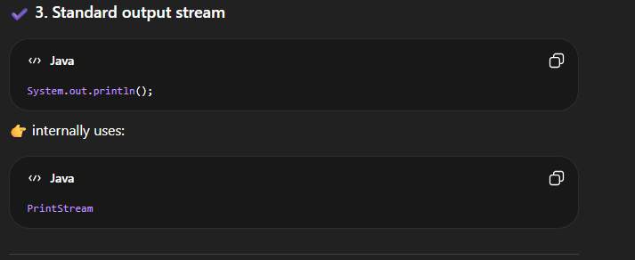
class Test{
public static void main(String args[]) throws Exception {
FileOutputStream fout =
new FileOutputStream("print.txt");
PrintStream p =
new PrintStream(fout);
p.println("Hello");
p.println(100);
p.println(99.9);
p.close();
fout.close();
System.out.println("Printed");
}
}

- Advantages Easy formatting,Convenient output
5. Random Access File
RandomAccessFile allows:
- reading
- writing
- accessing any position in file
Unlike normal streams,
you can move anywhere inside file.

Constructor
RandomAccessFile raf =new RandomAccessFile("file.txt", "rw");
Modes:
- "r" → read only
- "rw" → read and write

Example
import java.io.*;
⚡ Why 4 bytes in seek?
Because:
int = 4 bytes
So:
- 0 → first int
- 4 → second int
- 8 → third int

class Test{
public static void main(String args[]) throws Exception {
RandomAccessFile raf =
new RandomAccessFile("a.txt", "rw");
raf.writeInt(100);
raf.writeInt(200);
raf.writeInt(300);
// move to 2nd integer (index 1)
raf.seek(4); // 1 int = 4 bytes
System.out.println(raf.readInt());
raf.close();
}
}
Important Methods
Method | Work
seek(pos) | Moves file pointer
getFilePointer() | Current position
length() | File size
readInt() | Reads integer(FOR READCHAR CHAR ALSO)
writeInt() | Writes integer(FOR WRITECHAR CHAR ALSO)

Why Called Random Access?
Because data can be accessed in any order.
Example:
- jump directly to byte 50
- no need to read previous bytes

Difference Between Sequential and Random Access
Sequential Access | Random Access
Read from start | Read from any position
Slower for large jumps | Faster direct access
Used in streams | Used in RandomAccessFile

Complete Flow of Java I/O
Keyboard/File
↓
Input Stream
↓
Buffered/Data Filter
↓
Program
↓
Output Stream
↓
Screen/File
JDBC (Java Database Connectivity)
JDBC is a Java API used to:
👉 connect Java programs with databases and perform operations like insert, update, delete, and select.
🧠 Core Idea
Java Program → JDBC API → Database (MS-Access / Oracle / SQL Server)
It acts like a bridge between Java and database.

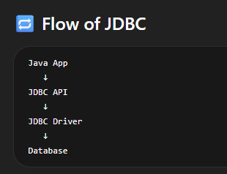
⚙️ JDBC Architecture
4 Main Components:
1. Java Application
Your program (JDBC code)
2. JDBC API
Provides classes/interfaces like:
- Connection
- Statement
- ResultSet
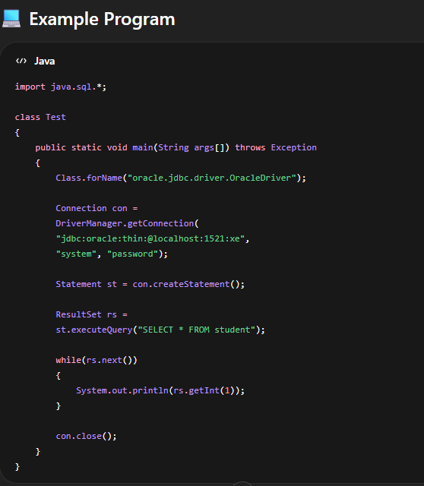
3. JDBC Driver
Converts Java calls → DB-specific calls
4. Database
MS-Access / Oracle / SQL Server
Steps to Use JDBC
🥇 Step 1: Load Driver
Class.forName("driver_name");
🥈 Step 2: Create Connection
Connection con =
DriverManager.getConnection(url, user, password);
🥉 Step 3: Create Statement
Statement st = con.createStatement();
🏁 Step 4: Execute Query
ResultSet rs = st.executeQuery("SELECT * FROM student");
🧹 Step 5: Close Connection
con.close();

🖨️ Output of your program
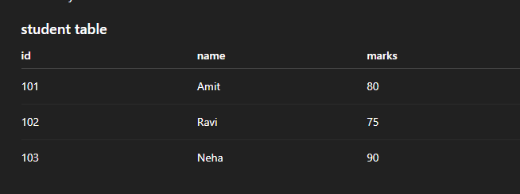
101
102
103
📊 JDBC Core Classes
Class | Purpose
DriverManager | manages drivers
Connection | connects DB
Statement | runs SQL queries
PreparedStatement | precompiled queries
ResultSet | stores output

⚡ Types of Statements
1. Statement
st.executeQuery("SELECT * FROM student");
✔ simple queries
❌ slow for repeated queries

2. PreparedStatement (Important)
PreparedStatement ps =
con.prepareStatement("SELECT * FROM student WHERE id=?");
✔ faster
✔ prevents SQL injection
✔ reusable

📦 ResultSet
Used to store query result:
while(rs.next())
{
System.out.println(rs.getString(1));
}

⚠️ Key Points for Exam
✔ JDBC is API for database connectivity
✔ Works with relational DBs
✔ Uses drivers for communication
✔ Supports SQL execution
✔ Platform independent
🧩 JDBC with Different Databases
🟦 1. MS-Access
- Driver: UCanAccess / JDBC-ODBC bridge (old)
- URL format:
jdbc:odbc:database_name

🟨 2. Oracle
- Driver:
oracle.jdbc.driver.OracleDriver
- URL format:
jdbc:oracle:thin:@localhost:1521:xe

🟥 3. MS-SQL Server
- Driver:
com.microsoft.sqlserver.jdbc.SQLServerDriver
- URL format:
jdbc:sqlserver://localhost:1433;databaseName=DB

Object Serialization (Java)
What is it?
Object Serialization is the process of converting a Java object into a byte stream so it can be stored in a file or sent over a network.

🧠 Why needed?
Normally:
- Objects exist only in memory ❌
- Cannot be stored directly in files or sent over network ❌
Serialization solves this.

🔁 Process
Object → Byte Stream → File / Network
Byte Stream → Object (Deserialization)

⚙️ How to do it?
Step 1: Make class Serializable
import java.io.*;
class Student implements Serializable{
int id;
String name;
}

Step 2: Write object
FileOutputStream fout = new FileOutputStream("a.txt");
ObjectOutputStream oos = new ObjectOutputStream(fout);
Student s = new Student();
s.id = 1;
s.name = "Anu";
oos.writeObject(s);
oos.close();

Step 3: Read object
FileInputStream fin = new FileInputStream("a.txt");
ObjectInputStream ois = new ObjectInputStream(fin);
Student s = (Student) ois.readObject();
System.out.println(s.name);

⚠️ Key Points
- Uses Serializable interface
- ObjectOutputStream → write object
- ObjectInputStream → read object
- Used in file storage + networking
Sockets (Networking)
📌 What is a Socket?
A socket is an endpoint for communication between two machines over a network.
A socket is an interface that enables communication between two machines over a network using IP address and port number.

🧠 Simple idea
Client ↔ Socket ↔ Server
How Socket Works
Each socket is identified by:
- IP Address → identifies machine
- Port Number → identifies application/service
Example:
192.168.1.10 : 8080
IP Address Port Number
🔁 Types
1. Stream Socket (TCP Socket)
📌 Uses TCP (Transmission Control Protocol)
Features:
- Reliable communication
Example use:
- Web browsing (HTTP/HTTPS)
- Banking apps
- File transfer

Java Classes:
- Socket
- ServerSocket
- Data arrives in order
- Connection-oriented
- Slower but safe

2. Datagram Socket (UDP Socket)
📌 Uses UDP (User Datagram Protocol)
Features:
Example use:
- Online gaming 🎮
- Live video streaming 📺
- Voice calls (VoIP)

Java Classes:
- DatagramSocket
- DatagramPacket

- Faster communication
- No guarantee of delivery
- Connectionless
- Data may arrive out of order

⚖️ TCP vs UDP
Feature | TCP (Stream Socket) | UDP (Datagram Socket)
Connection | Yes | No
Speed | Slow | Fast
Reliability | High | Low
Order | Maintained | Not guaranteed
Example | Web, email | Gaming, video call

A socket = IP address + Port number + Protocol (TCP/UDP)
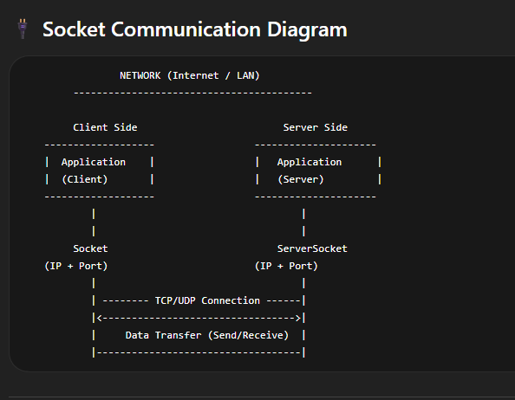

Client
import java.net.*;
class Client{
public static void main(String args[]) throws Exception {
Socket s = new Socket("localhost", 5000);
System.out.println("Connected to Server");
s.close();
}
}
Server
import java.net.*;
class Server{
public static void main(String args[]) throws Exception{
ServerSocket ss = new ServerSocket(5000);
Socket s = ss.accept();
System.out.println("Client Connected");
ss.close();
}
}

Client–Server Application
📌 What is it?
A Client–Server application is a network model where:{ is a distributed system i}
- Client requests data or service
- Server provides response or service
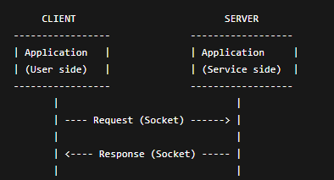
🧠 Architecture

⚙️ How it works (Step-by-step)
🔹 Server side
- Creates ServerSocket
- Waits for client connection (accept())
- Receives request
- Sends response
🔹 Client side
- Creates Socket
- Connects to server (IP + Port)
- Sends request
- Receives response

📌 Example Idea
Same as above
📌 Disadvantages
- Server failure affects all clients
- Can become slow if many clients connect

📌 Advantages
- Centralized data (server)
- Easy maintenance
- Secure control
- Efficient resource sharing

⚖️ Features
- Uses sockets
- Works over TCP/UDP
- Supports multiple clients (in advanced systems)
- Distributed communication

Multithreaded Server
📌 What is it?
A multithreaded server is a server that can handle multiple clients at the same time using threads.
A multithreaded server is a server that creates a separate thread for each client connection, allowing multiple clients to communicate with the server simultaneously.
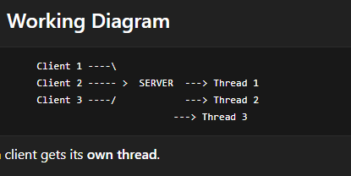
⚙️ How it works
- Server waits for client connection
- When client connects:
  - A new thread is created
- That thread handles the client
- Server goes back to accept new clients
📌 Disadvantages
- Complex programming
- High memory usage (many threads)
- Need synchronization in real systems

ccdv

📌 Advantages
- Handles multiple clients simultaneously
- Fast response time
- Efficient resource usage
- Scalable system

vdjnvd

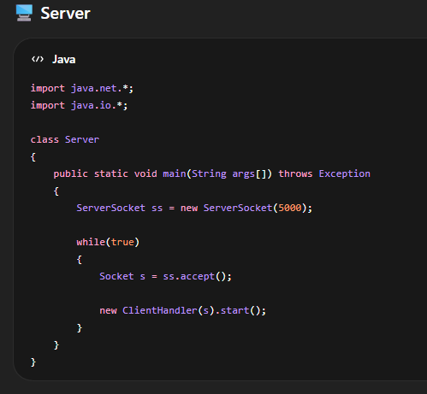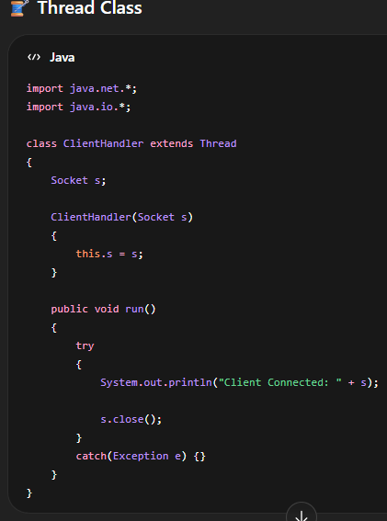

Remote Method Invocation (RMI)
RMI is a mechanism in Java that allows an object in one JVM to invoke methods of an object in another JVM (remote machine).
Simple Idea
Client JVM → Server JVM
method call across network
So you can call methods remotely like local methods.

Architecture
Client → Stub → RMI Registry → Skeleton → Server
Object
Main Components of RMI
1. Remote Interface
- Declares methods that can be called remotely
💡 Features
✔ Distributed computing
✔ Object-oriented networking
✔ Secure communication
✔ Method calling like local program

2. Implementation Class
- Implements remote interface
3. Stub (Client side proxy)
- Sends request to server
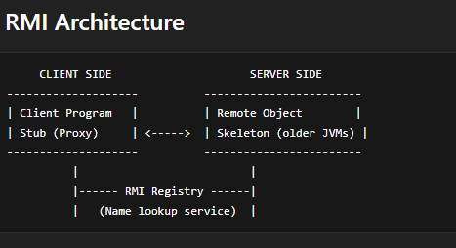
4. Skeleton (Server side, older Java)
- Receives request (now handled internally)
5. RMI Registry
- Stores and finds remote objects
🔁 Working Flow
- Server creates remote object
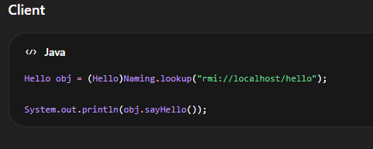
- Registers it in RMI registry
- Client looks up object
- Client calls method via stub
- Server executes method
- Result sent back
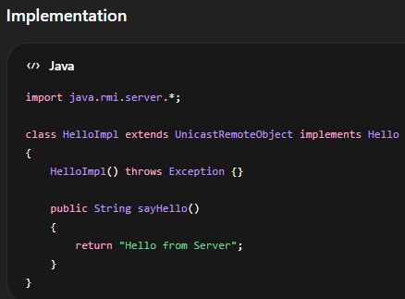
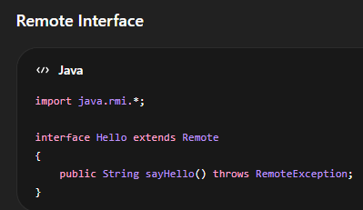

,

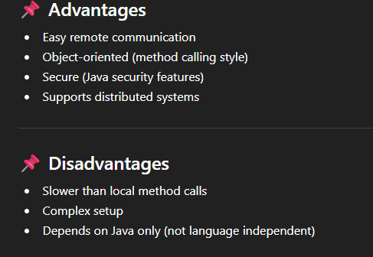
Java Native Interface (JNI)
📌 What is JNI?
JNI (Java Native Interface) is a framework that allows Java code to interact with programs written in other languages like C or C++.
🧠 Why JNI is needed?
⚙️ Why JNI is used?
- Performance improvement (C/C++ is faster)
- Hardware interaction (drivers, devices)
- Reusing old C/C++ code
- System-level programming

Example Idea
- Java program → calls C function → gets result back

Java is: platform independent ✔
- but sometimes slow for system-level tasks ❌
🔧 How JNI works (Steps)
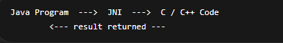
- Write Java program with native keyword
- Load native library
- Declare native method
- Implement method in C/C++
- Link with Java using JNI

💻 Example (Java side)
C Code (Native Implementation)
#include <jni.h>
#include <stdio.h>
#include "Test.h"

JNIEXPORT void JNICALL Java_Test_show(JNIEnv *env, jobject obj)
{
printf("Hello from C code\n");
}
class Test{
// native method declaration
public native void show();
static {
System.loadLibrary("mycode");
}
public static void main(String args[]) {
new Test().show();
}
}
💡 Keywords
Keyword | Meaning
native | method written in C/C++
System.loadLibrary() | loads native code

🧱 3. Development of JNI-based Application
📌 Steps
1. Write Java Program (with native method)
2. Compile Java Code
3. Generate Header File (.h)
4. Write C/C++ Implementation
5. Compile C Code into Library (.dll / .so)
6. Run Java Program

🥇 Step 1: Write Java Program
class Test{
// native method declaration
public native void show();
static {
System.loadLibrary("mycode");
}
public static void main(String args[]) {
new Test().show(); }
}
🥈 Step 2: Generate Header File
javac Test.java
javah Test
👉 creates .h file for C/C++

🥉 Step 3: Write C Program
#include <jni.h>
#include "Test.h"
#include <stdio.h>
JNIEXPORT void JNICALL
Java_Test_show
(JNIEnv *env, jobject obj)
{
printf("Hello from C code");
}

🏁 Step 4: Compile C Code into DLL/Shared Library
gcc -shared -o mylib.dll Test.c

🚀 Step 5: Run Java Program
Output:
Hello from C code

java Test

📦 Java Collection API (Framework)
📌 What is Collection API?
Collection API is a set of interfaces + classes in Java used to store and manipulate groups of objects.

🧠 Hierarchy (Basic Idea)
Collection
/ | \
List Set Queue
Map (separate hierarchy, NOT part of Collection interface)

📜 1. List Interface
📌 What is List?
A List is an ordered collection that allows duplicate elements.

💡 Features
📌 Common Implementations
- ArrayList
- Vector
- Stack

✔ Maintains insertion order
✔ Allows duplicates
✔ Indexed access (like arrays)
Example (List)
import java.util.*;
class Test
{
public static void main(String args[]) {
List<Integer> l = new ArrayList<>();
l.add(10);
l.add(20);
l.add(10);
System.out.println(l);
}
}

🧾 2. Set Interface
📌 What is Set?
A Set is a collection that does NOT allow duplicates.
📌 Implementations
- HashSet
- LinkedHashSet
- TreeSet

💡 Features
✔ No duplicate elements
✔ Unordered (mostly)
✔ Fast lookup
Example (Set)
import java.util.*;
class Test{
public static void main(String args[]) {
Set<Integer> s = new HashSet<>();
s.add(10);
s.add(20);
s.add(10);
System.out.println(s);
}}
🗺️ 3. Map Interface
📌 What is Map?
Map stores data in key-value pairs.
Common Classes:
- HashMap
- Hashtable
- TreeMap

💡 Features
✔ Keys are unique
✔ Values can repeat
✔ No duplicate keys allowed
📌 Example (Map)
import java.util.*;
class Test{
public static void main(String args[]) {
Map<Integer, String> m = new HashMap<>();
m.put(1, "Amit");
m.put(2, "Ravi");
System.out.println(m);
}
}
📦 4. Vector Class
📌 What is Vector?
Vector is a dynamic array that grows automatically and is synchronized.

💡 Features
✔ Thread-safe (synchronized)
✔ Allows duplicates
✔ Slower than ArrayList

Example
import java.util.*;
class Test{
public static void main(String args[]) {
Vector<Integer> v = new Vector<>();
v.add(10);
v.add(20);
System.out.println(v);
}
}

📦 5. Stack Class
📌 What is Stack?
Stack is a LIFO (Last In First Out) data structure.

💡 Operations
Method | Meaning
push() | add element
pop() | remove element
peek() | view top

Example
import java.util.*;
class Test{
public static void main(String args[]{
Stack<Integer> s = new Stack<>();
s.push(10);
s.push(20);
System.out.println(s.pop());
}
}

📦 6. Hashtable
📌 What is Hashtable?
Hashtable stores data in key-value pairs and is synchronized.

💡 Features
✔ No null key or value
✔ Thread-safe
✔ Slower than HashMap

💻 Example
Hashtable<Integer, String> ht =
new Hashtable<>();

ht.put(1, "A");
ht.put(2, "B");

🔁 7. Enumeration
📌 What is Enumeration?
Enumeration is used to iterate elements in Vector/Hashtable (legacy).

💡 Methods
Method | Meaning
hasMoreElements() | check next element
nextElement() | get next element

Example
import java.util.*;
class Test{
public static void main(String args[]) {
Vector<Integer> v = new Vector<>();
v.add(10);
v.add(20);
Enumeration<Integer> e = v.elements();
while(e.hasMoreElements())
{
System.out.println(e.nextElement());
}
}
}

🔁 8. Iterator
📌 What is Iterator?
Iterator is used to traverse all collection types (modern approach).

💡 Methods
Method | Meaning
hasNext() | check next element
next() | get next element
remove() | delete element

💻 Example
import java.util.*;
class Test{
public static void main(String args[]) {
List<Integer> l = new ArrayList<>();
l.add(10);
l.add(20);
Iterator<Integer> it = l.iterator();
while(it.hasNext())
{
System.out.println(it.next());
}
}
}

Type | Description
List | Ordered, duplicates allowed
Set | No duplicates
Map | Key-value pairs
Vector | Thread-safe list
Stack | LIFO structure
Enumeration | Legacy traversal
Iterator | Modern traversal

